**Program Structure**

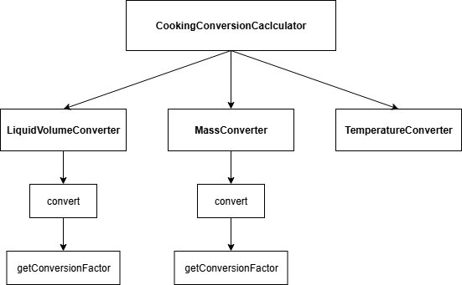

**Top-down Integration**

|  |  |  |  |  |  |  |
| --- | --- | --- | --- | --- | --- | --- |
| **Unit under test** | **List of Stubs/Drivers** | **Result** | **Stub’s return value** | **Expected results** | **Actual results** | **Pass/Fail/No run** |
| CookingConversionCalculator.convert(100, "temperature", "fahrenheit", "celsius") | Stub TemperatureConverter (mocked return 37.78) | 37.78 | 37.78 | 37.78 | 37.78 | Pass |
| CookingConversionCalculator.convert(2, "mass", "cup", "gram") | ใช้ Driver เรียก MassConverter จริง | 250 | - | 250 | 250 | Pass |
| CookingConversionCalculator.convert(1, "liquid", "cup", "ml") | ใช้ Driver เรียก LiquidVolumeConverter จริง | 250 | - | 250 | 250 | Pass |
| CookingConversionCalculator.convert(1, "liquid", "cup", "ml") | ใช้ Driver เรียก LiquidVolumeConverter จริง | 250 | - | 250 | 250 | Pass |
| CookingConversionCalculator.convert(212, "temperature", "fahrenheit", "celsius") | ใช้ TemperatureConverter จริง | 100.0 | - | 100.0 | 100.0 | Fail |
|  |  |  |  |  |  |  |
|  |  |  |  |  |  |  |
|  |  |  |  |  |  |  |
|  |  |  |  |  |  |  |

**Bottom-up Integration**

|  |  |  |  |  |  |  |
| --- | --- | --- | --- | --- | --- | --- |
| **Unit under test** | **List of Stubs/Drivers** | **Result** | **Stub’s return value** | **Expected results** | **Actual results** | **Pass/Fail/No run** |
| TemperatureConverter.convert(212, "fahrenheit", "celsius") | Driver (JUnit test) | 100.0 | - | 100.0 | 100.0 | Pass |
| TemperatureConverter.convert(100, "celsius", "fahrenheit") | Driver (JUnit test) | 212.0 | - | 212.0 | 0 | Fail |
| MassConverter.convert(2, "cup", "gram") | Driver (JUnit test) | 250 | - | 250 | 250 | Pass |
| MassConverter.convert(3, "tablespoon", "gram") | Driver (JUnit test) | 24 | - | 24 | 24 | Pass |
| LiquidVolumeConverter.convert(1, "cup", "ml") | Driver (JUnit test) | 250 | - | 250 | 250 | Pass |
| LiquidVolumeConverter.convert(2, "tablespoon", "ml") | Driver (JUnit test) | 30 | - | 30 | 30 | Pass |
| CookingConversionCalculator.convert(2, "mass", "cup", "gram") | Driver → เรียกใช้ MassConverter จริง | 250 | - | 250 | 250 | Pass |
| CookingConversionCalculator.convert(1, "liquid", "cup", "ml") | Driver → เรียกใช้ LiquidVolumeConverter จริง | 250 | - | 250 | 250 | Pass |
| CookingConversionCalculator.convert(212, "temperature", "fahrenheit", "celsius") | Driver → เรียกใช้ TemperatureConverter จริง | 100.0 | - | 100.0 | 0 | Fail |
|  |  |  |  |  |  |  |
|  |  |  |  |  |  |  |